Instructions and Formatting Rules for Authors

**First author1, Second author2, Third author3 (Times New Roman 11pt)**

1First author affiliation, University/Institute (Times New Roman, 10pt); Email address (9pt)

2Second author affiliation, University/Institute (Times New Roman, 10pt); Email address (9pt)

3Third author affiliation, University/ Institute (Times New Roman, 10pt); Email address (9pt)

* Corresponding author: Name

**Abstract**

In this manuscript, basic instructions for the preparation of a paper are presented. This document is an example of the desired layout and can be used as a template. The document contains information for all formats, type sizes, and typefaces in the required styles. Style rules are provided to explain how to handle equations, units, figures, tables, abbreviations, and acronyms. The English abstract is limited to 250 words in one paragraph. It should concisely state explicitly the subject or the problem, the methodology, the principal results, and their significance.

**Keywords:** Up to 6 Words, Separated by Comma.

# Introduction

This instruction gives you guidelines for preparing the papers. All papers must be submitted electronically in Docx format. Prepare your paper in A4 page size of 210 mm × 297 mm (8.27" × 11.69"). The length of your paper should not exceed 15 pages. Do not include page numbers.

Set the top margin to 1.5" and the bottom margin to 0.5". Left and right margins should be 0.59" and gutter 0. Header and footer 0" and 0.5", respectively. Use a single-column format and single spacing.

# Prepare your paper before styling

Before you begin to format your paper, first write and save the content as a separate text file. Complete all content and organizational editing before formatting. Please note sections A-D below for more information on proofreading, spelling, and grammar.

Keep your text and graphic files separate until after the text has been formatted and styled. Do not use hard tabs, and limit the use of hard returns to only one return at the end of a paragraph. Do not add any kind of pagination anywhere in the paper. Do not number text heads-the template will do that for you.

## Equations

The text size of the formula should be similar to the body text size. The formula should be placed in the middle and the serial number on the right. For example:

|  |  |
| --- | --- |
| $$a^{2}+b^{2}=c^{2}$$ | (1) |

To make your equations more compact, you may use the solidus ( / ), the exp function, or appropriate exponents. Italicize Roman symbols for quantities and variables, but not Greek symbols.

# Figures and Tables

All of the Tables and Figures must be in the center of the page. The title of the Tables must be at the top of the Table and the title of the Figures must be below them at the center. Insert figures and tables after they are cited in the text.

Table 1-Table Type Styles

|  |  |  |  |
| --- | --- | --- | --- |
| Subject | Font | Size | Type |
| Paper Title | Times New Roman | 14 | Bold |
| Name and Family of Authors | Times New Roman | 11 | Bold |
| Affiliation of Authors | Times New Roman | 10 | Normal |
| Section Title | Times New Roman | 12 | Bold |
| Section Subtitle | Times New Roman | 11 | Bold |
| Abstract text | Times New Roman | 11 | Normal |
| Keywords | Times New Roman | 11 | Normal |
| Body text | Times New Roman | 11 | Normal |
| Footnotes | Times New Roman | 9 | Normal |
| Title of Tables and Figures | Times New Roman | 10 | Normal |
| Text of Tables | Times New Roman | 10 | Normal |
| References | Times New Roman | 11 | Normal |

1. Sample of a Table footnote. (*Table footnote*)

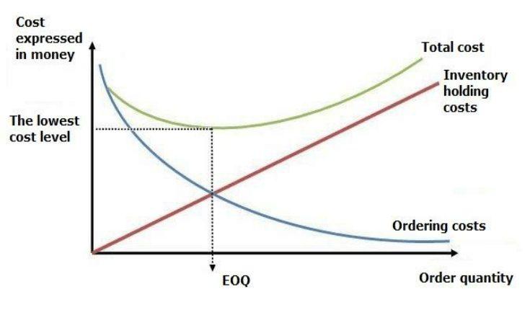

Figure 1-Figure title

Acknowledgments

Identify grants or other financial support (and the source, if appropriate) for your study. Thanks to those who helped with the preparation of the article indirectly.

References

The template will number citations consecutively within brackets [1]. The sentence punctuation follows the bracket [2]. Refer simply to the reference number, as in [3]—do not use “Ref. [3]” or “reference [3]” except at the beginning of a sentence: “Reference [3] was the first ...”

Number footnotes separately in superscripts. Place the actual footnote at the bottom of the column in which it was cited. Do not put footnotes in the abstract or reference list. Use letters for table footnotes.

Unless there are six authors or more give all authors’ names; do not use “et al.”. Capitalize only the first word in a paper title, except for proper nouns and element symbols.

1. G. Eason, B. Noble, and I. N. Sneddon, “On certain integrals of Lipschitz-Hankel type involving products of Bessel functions,” Phil. Trans. Roy. Soc. London, vol. A247, pp. 529–551, April 1955. *(references)*
2. J. Clerk Maxwell, A Treatise on Electricity and Magnetism, 3rd ed., vol. 2. Oxford: Clarendon, 1892, pp.68–73.
3. I. S. Jacobs and C. P. Bean, “Fine particles, thin films and exchange anisotropy,” in Magnetism, vol. III, G. T. Rado and H. Suhl, Eds. New York: Academic, 1963, pp. 271–350.
4. K. Elissa, “Title of paper if known,” unpublished.
5. R. Nicole, “Title of paper with only first word capitalized,” J. Name Stand. Abbrev., in press.
6. Y. Yorozu, M. Hirano, K. Oka, and Y. Tagawa, “Electron spectroscopy studies on magneto-optical media and plastic substrate interface,” IEEE Transl. J. Magn. Japan, vol. 2, pp. 740–741, August 1987 [Digests 9th Annual Conf. Magnetics Japan, p. 301, 1982].
7. M. Young, The Technical Writer’s Handbook. Mill Valley, CA: University Science, 1989.